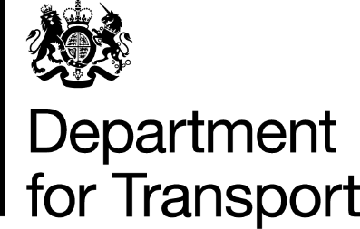

Notification form to Department for Transport to inform that relaxations will be used.

Please fill out all the fields below and send your completed form by email to RSSSFOLRCOVID19@dft.gov.uk

Name of operator

Operator Licence Number(s)

Name of responsible transport manager(s)

Do you plan to use the increased daily driving limit?

Do you plan to use alternative pattern of weekly rest periods and the increased fortnightly driving limit?

What type of loads will be carried?

This form should be sent within 24 hours of when the operator starts to use the relaxations.
Failure to comply with the above would be an indication to enforcement authorities that
the relaxations may be being used inappropriately and follow-up investigatory action
could occur.

